# Class Diagram

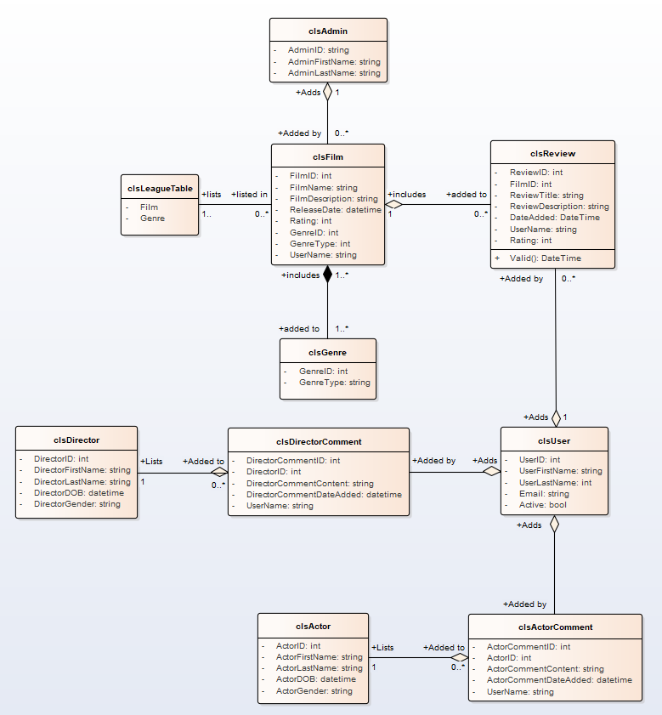

# Use Case Descriptions

## Admin - Login

|  |  |
| --- | --- |
| Use Case Name (Short two or three word name) | Login |
| Precondition |  |
| Use Case Author(s) (Who wrote this) | Nneka |
| Actor(s) (Who does this) | Admin |
| Locations (Where does this happen) | Online |
| Primary pathway (What is the normal “happy path” for this use case?) | 1. Admin selects Login on website 2. System returns login fields 3. Admin enters details in text boxes 4. System returns main page |
| Alternate pathways (What other paths are there that are not the “happy path”?) | 1. Admin selects Login on website 2. System returns login fields 3. Admin enters details in text boxes 4. System returns error message 5. Admin enters correct details 6. System returns main page |
| Exception pathways (What could possibly go wrong?) | System login fails  System crashes |

## Admin – Add Film Description

|  |  |
| --- | --- |
| Use Case Name (Short two or three word name) | Add Film Description |
| Precondition | Admin is logged into the system |
| Use Case Author(s) (Who wrote this) | Nneka |
| Actor(s) (Who does this) | Admin |
| Locations (Where does this happen) | Online |
| Primary pathway (What is the normal “happy path” for this use case?) | 1. Admin selects ‘Add Film’ from main page 2. System returns text box fields to enter film details 3. Admin enters film description in text boxes 4. Admin selects ‘Add’ in the system 5. System returns confirmation dialogue 6. Admin selects ‘OK’ to confirm details 7. System returns new film added to the list |
| Alternate pathways (What other paths are there that are not the “happy path”?) | 1. Admin selects ‘Add Film’ from main page 2. System returns text box fields to enter film details 3. Admin enters film description in text boxes 4. Admin selects ‘Add’ in the system 5. System returns error message 6. Admin enters correct data for film description 7. System returns confirmation dialogue 8. Admin selects ‘OK’ to confirm details 9. System returns new film added to the list |
| Exception pathways (What could possibly go wrong?) | Film is not added to the list of films  System crashes |

## Admin – Add Gossip Page

|  |  |
| --- | --- |
| Use Case Name (Short two or three word name) | Add Gossip Page |
| Precondition | Admin has confirmed new film added to the system |
| Use Case Author(s) (Who wrote this) |  |
| Actor(s) (Who does this) | Admin |
| Locations (Where does this happen) | Online |
| Primary pathway (What is the normal “happy path” for this use case?) | 1. Admin selects ‘Add Gossip Page’ in website 2. System returns textboxes for gossip page details 3. Admin enters film title of gossip page 4. Admin selects ‘Add’ in the system 5. System returns confirmation dialogue 6. Admin selects ‘OK’ to confirm details 7. System returns new gossip page linked to the film |
| Alternate pathways (What other paths are there that are not the “happy path”?) | 1. Admin selects ‘Add Gossip Page’ in website 2. System returns textboxes for gossip page details 3. Admin enters film title to gossip page 4. Admin selects ‘Add’ in the system 5. System returns error message 6. Admin enters correct data for gossip page 7. System returns confirmation dialogue 8. Admin selects ‘OK’ to confirm details 9. System returns new film added to the list |
| Exception pathways (What could possibly go wrong?) | Gossip page is not added to the list of films  System crashes |

## Admin – Add Actor Page

|  |  |
| --- | --- |
| Use Case Name (Short two or three word name) | Add Actor Page |
| Precondition | Film description has been added |
| Use Case Author(s) (Who wrote this) |  |
| Actor(s) (Who does this) | Admin |
| Locations (Where does this happen) | Online |
| Primary pathway (What is the normal “happy path” for this use case?) | 1. Admin selects ‘Actor’ to add to film details 2. System returns textboxes for Actor’ details 3. Admin enters details for Actor into system 4. Admin selects ‘Add’ in the system 5. System returns confirmation dialogue 6. Admin selects ‘OK’ to confirm details 7. System returns Actor added to film details page |
| Alternate pathways (What other paths are there that are not the “happy path”?) | 1. Admin selects ‘Actor’ to film in website 2. System returns textboxes for Actor’ details 3. Admin enters details for Actor into system 4. Admin selects ‘Add’ in the system 5. System returns error message 6. Admin enters correct data for actor 7. System returns confirmation dialogue 8. Admin selects ‘OK’ to confirm details 9. System returns new actor added to film details page |
| Exception pathways (What could possibly go wrong?) | Actor is not added to film details  System crashes |

## Admin – Add Director Page

|  |  |
| --- | --- |
| Use Case Name (Short two or three word name) | Add Director Page |
| Precondition | Film description has been added |
| Use Case Author(s) (Who wrote this) |  |
| Actor(s) (Who does this) | Admin |
| Locations (Where does this happen) | Online |
| Primary pathway (What is the normal “happy path” for this use case?) | 1. Admin selects ‘Director’ to add to film details 2. System returns textboxes for Director details 3. Admin enters details for Director into system 4. Admin selects ‘Add’ in the system 5. System returns confirmation dialogue 6. Admin selects ‘OK’ to confirm details 7. System returns Director added to film details page |
| Alternate pathways (What other paths are there that are not the “happy path”?) | 1. Admin selects ‘Director’ to film in website 2. System returns textboxes for Director details 3. Admin enters details for Director into system 4. Admin selects ‘Add’ in the system 5. System returns error message 6. Admin enters correct data for Director 7. System returns confirmation dialogue 8. Admin selects ‘OK’ to confirm details 9. System returns new Director added to film details page |
| Exception pathways (What could possibly go wrong?) | Actor is not added to film details  System crashes |

## Admin – (Moderate) Update Comment

|  |  |
| --- | --- |
| Use Case Name (Short two or three word name) | (Moderate) Update Comment |
| Precondition |  |
| Use Case Author(s) (Who wrote this) | Nneka |
| Actor(s) (Who does this) | Admin |
| Locations (Where does this happen) | Online |
| Primary pathway (What is the normal “happy path” for this use case?) | 1. Admin selects comment under Actor/Director details 2. System returns comment highlighted 3. Admin selects ‘edit comment’ under comment 4. System returns ‘edit’ functionality for admin 5. Admin edits comment Actor/Director details 6. Admin selects ‘Confirm Changes’ under comment 7. System returns confirmation dialogue to admin 8. Admin confirms changes to the comment 9. System returns comment with updated edit |
| Alternate pathways (What other paths are there that are not the “happy path”?) |  |
| Exception pathways (What could possibly go wrong?) | Comment is not deleted from comments section  System crashes |

## Admin – Delete Comment

|  |  |
| --- | --- |
| Use Case Name (Short two or three word name) | Delete Comment |
| Precondition |  |
| Use Case Author(s) (Who wrote this) | Nneka |
| Actor(s) (Who does this) | Admin |
| Locations (Where does this happen) | Online |
| Primary pathway (What is the normal “happy path” for this use case?) | 1. Admin selects comment under Actor/Director details 2. System returns comment highlighted 3. Admin selects ‘delete comment’ under comment 4. System returns confirmation dialogue to admin 5. Admin confirms delete of comment 6. System returns Actor/Director comments with comment deleted |
| Alternate pathways (What other paths are there that are not the “happy path”?) |  |
| Exception pathways (What could possibly go wrong?) | Comment is not deleted from comments section  System crashes |

## Admin – Suspend User

|  |  |
| --- | --- |
| Use Case Name (Short two or three word name) | Suspend User |
| Precondition |  |
| Use Case Author(s) (Who wrote this) | Nneka |
| Actor(s) (Who does this) | Admin |
| Locations (Where does this happen) | Online |
| Primary pathway (What is the normal “happy path” for this use case?) | 1. Admin selects ‘Users’ from list in main page 2. System returns list of active users in the system 3. Admin selects text box in the system 4. System highlights text box selected by admin 5. Admin enters user name in text box 6. System filters user names of active users in the system 7. Admin selects user from the list 8. Admin selects ‘View details’ in the system 9. System returns user details with ‘Active’ checkbox 10. Admin unchecks ‘Active’ textbox under user details 11. Admin selects ‘Save details’ in user page 12. System returns confirmation dialogue 13. Admin confirms changes to use details |
| Alternate pathways (What other paths are there that are not the “happy path”?) |  |
| Exception pathways (What could possibly go wrong?) |  |

## User – Add User

|  |  |
| --- | --- |
| Use Case Name (Short two or three word name) | Add User |
| Precondition |  |
| Use Case Author(s) (Who wrote this) | Nneka |
| Actor(s) (Who does this) | User |
| Locations (Where does this happen) | Online |
| Primary pathway (What is the normal “happy path” for this use case?) | 1. User selects ‘Sign-up’ on main page 2. System returns sign-up textboxes 3. User enters personal details in required fields 4. User selects ‘Add Account’ at the bottom of page 5. System returns confirmation dialogue to user 6. User confirms details in the system 7. System stores new user details in database 8. System returns to the main page of the website |
| Alternate pathways (What other paths are there that are not the “happy path”?) | 1. User selects ‘Sign-up’ on main page 2. System returns sign-up textboxes 3. User enters personal details in required fields 4. User selects ‘Add Account’ at the bottom of page 5. System returns error message 6. User enters correct data type for fields 7. System returns confirmation dialogue 8. User selects ‘OK’ to confirm details 9. System stores new user details in database 10. System returns to the main page of the website |
| Exception pathways (What could possibly go wrong?) | System crashes  User details is not added to the system |

## User - Login

|  |  |
| --- | --- |
| Use Case Name (Short two or three word name) | Login |
| Precondition |  |
| Use Case Author(s) (Who wrote this) | Nneka |
| Actor(s) (Who does this) | User |
| Locations (Where does this happen) | Online |
| Primary pathway (What is the normal “happy path” for this use case?) | 1. User selects Login on website 2. System returns login fields 3. User enters details in the text boxes 4. System returns main page of website |
| Alternate pathways (What other paths are there that are not the “happy path”?) | 1. User selects Login on website 2. System returns login fields 3. User enters login details in text boxes 4. System returns error message 5. User enters correct details where errors occur 6. System returns main page of website |
| Exception pathways (What could possibly go wrong?) | System login fails  System crashes |

## User – Add Review

|  |  |
| --- | --- |
| Use Case Name (Short two or three word name) | Add Review |
| Precondition |  |
| Use Case Author(s) (Who wrote this) | Nneka |
| Actor(s) (Who does this) | User |
| Locations (Where does this happen) | Online |
| Primary pathway (What is the normal “happy path” for this use case?) | 1. User selects film from list of films 2. System displays film description to user 3. User selects ‘Add Review’ on film description page 4. System returns text boxes to enter film review 5. User enters review details in the system 6. User selects ‘Complete’ at the bottom of the review 7. System returns confirmation dialogue for review 8. User selects ‘OK’ to confirm new review details entered 9. System returns film description page with new review at the top. |
| Alternate pathways (What other paths are there that are not the “happy path”?) | 1. User selects film from list of films 2. System displays film description to user 3. User selects ‘Add Review’ on film description page 4. System returns text boxes to enter film review 5. User enters review details in the system 6. User selects ‘Complete’ at the bottom of the review 7. System returns error message 8. User enters correct details where errors occur 9. System returns main page of website |
| Exception pathways (What could possibly go wrong?) |  |

## User – Rate Review

|  |  |
| --- | --- |
| Use Case Name (Short two or three word name) | Rate Review |
| Use Case Description (Short description) |  |
| Use Case Author(s) (Who wrote this) |  |
| Actor(s) (Who does this) | User |
| Locations (Where does this happen) |  |
| Primary pathway (What is the normal “happy path” for this use case?) |  |
| Alternate pathways (What other paths are there that are not the “happy path”?) |  |
| Exception pathways (What could possibly go wrong?) |  |

## User – Add Comment

|  |  |
| --- | --- |
| Use Case Name (Short two or three word name) | Add Comment |
| Use Case Description (Short description) |  |
| Use Case Author(s) (Who wrote this) |  |
| Actor(s) (Who does this) | User |
| Locations (Where does this happen) |  |
| Primary pathway (What is the normal “happy path” for this use case?) |  |
| Alternate pathways (What other paths are there that are not the “happy path”?) |  |
| Exception pathways (What could possibly go wrong?) |  |

## User – Reply Comment

|  |  |
| --- | --- |
| Use Case Name (Short two or three word name) | Reply Comment |
| Use Case Description (Short description) |  |
| Use Case Author(s) (Who wrote this) |  |
| Actor(s) (Who does this) | User |
| Locations (Where does this happen) |  |
| Primary pathway (What is the normal “happy path” for this use case?) |  |
| Alternate pathways (What other paths are there that are not the “happy path”?) |  |
| Exception pathways (What could possibly go wrong?) |  |

## User – List Film

|  |  |
| --- | --- |
| Use Case Name (Short two or three word name) | List Film |
| Use Case Description (Short description) |  |
| Use Case Author(s) (Who wrote this) |  |
| Actor(s) (Who does this) | User |
| Locations (Where does this happen) |  |
| Primary pathway (What is the normal “happy path” for this use case?) |  |
| Alternate pathways (What other paths are there that are not the “happy path”?) |  |
| Exception pathways (What could possibly go wrong?) |  |

## User – Add Gossip

|  |  |
| --- | --- |
| Use Case Name (Short two or three word name) | Add Gossip |
| Use Case Description (Short description) |  |
| Use Case Author(s) (Who wrote this) |  |
| Actor(s) (Who does this) | User |
| Locations (Where does this happen) |  |
| Primary pathway (What is the normal “happy path” for this use case?) |  |
| Alternate pathways (What other paths are there that are not the “happy path”?) |  |
| Exception pathways (What could possibly go wrong?) |  |